05/10/13

CAP 221

Final Project

Plan of Instruction

Effective Date: Spring 2013 Version Number: 2013-1

COURSE DESCRIPTION:

This course allows the student to create a final project showcasing his strength and abilities under the supervision and counseling of a professional visual effects artist. Upon completion, the student should be able to showcase their talent and be ready to work in a VFX company.

CREDIT HOURS

Theory Credit Hours 1 hour
Lab Credit Hours 5 hours
Total Credit Hours 6 hours

NOTE: Theory credit hours are a 1:1 contact to credit ratio. Colleges may schedule lab hours as 3:1 and/or 2:1 contact to credit ratio. Clinical hours are 3:1 contact to credit ratio. (Ref Board Policy 705.01)

PREREQUISITE COURSES

CAP 202

CO-REQUISITE COURSES

As determined by college.

PROFESSIONAL COMPETENCIES
- Create and revise a complete CGI project.
- Value the importance of a good plan when managing a project.
- Coordinate various CGI skills to complete a CGI project.
- Explain the importance of the review process.

INSTRUCTIONAL GOALS

- Cognitive – Comprehend principles and concepts related to CGI project creation.

- Psychomotor – Apply principles and concepts related to CGI project creation.

- Affective – Value the importance of principles and concepts related to CGI project creation.

STUDENT OBJECTIVES

Condition Statement: Unless otherwise indicated, evaluation of student’s attainment of objectives is based on knowledge gained from this course. Specifications may be in the form of, but not limited to, cognitive skills diagnostic instruments, manufacturer’s specifications, technical orders, regulations, national and state codes, certification agencies, locally developed lab/clinical assignments, or any combination of specifications.

STUDENT LEARNING OUTCOMES

MODULE A – CREATE A COMPLETE CGI PROJECT
MODULE DESCRIPTION – This module guides students on creating and revising a complete CGI project. Topics include defining the project’s scope, concept and previz approval, live action shooting, managing a work schedule, troubleshooting, third party expectations, project management, and presentation.
PROFESSIONAL COMPETENCIES | PERFORMANCE OBJECTIVES | KSA
A1.0 Create and revise a complete CGI project. | A1.1 Demonstrate the ability to present ideas clearly.  A1.1 Demonstrate the ability to schedule and work accordingly in order to meet deadlines.  A1.1 Demonstrate the ability to resolve ongoing problems and revise the project subsequently.  A1.1 Demonstrate the ability to present the completed project. | 4  4  3  4
A2.0 Value the importance of a good plan when managing a project. | A2.1 This competency is measured cognitively. | A
LEARNING OBJECTIVES |  | KSA
A1.1.1 Explain how to limit the scope of a project to produce the quality output required.  A1.1.2 Identify the processes related to the developing of a CGI project.  A1.1.3 Describe the upside and downside of working as a team.  A1.1.4 Discuss the need for presenting ideas clearly.  A1.1.5 Describe how to schedule and work accordingly in order to meet deadlines.  A1.1.6 Discuss the need for resolving ongoing problems and revising the project subsequently.  A1.1.7 Assess third party expectations and revise the project consequently. |  | 3  4  3  4  4  3  4
MODULE A OUTLINE:
- Define project scope based on available resources (teammates, time, rendering time)
- Concept and previz approval
- Live action shoot preparation
- Managing a work planning schedule
- Troubleshooting
- Third party expectations
- Project management
- Final presentation

LEARNING OUTCOMES Table of specifications
The table below identifies the percentage of learning objectives for each module. Instructors should develop sufficient numbers of test items at the appropriate level of evaluation.

 | Limited Knowledge and Proficiency | Moderate Knowledge and Proficiency | Advanced Knowledge and Proficiency | Superior Knowledge and Proficiency
KSA | 1 | 2 | 3 | 4
Module A |  |  | 37% | 63%

The KSA is NOT determined by the verb used in the learning objective, but rather in the context in which the verb is used and the depth of knowledge and skills required.

Example: Three KSA levels using the same verb (describe):
KSA 1 – Describe three characteristics of metamorphic rocks. (Simple recall)
KSA 2 – Describe the difference between metamorphic and igneous rocks. (requires cognitive processing to determine the differences in the two rock types)
KSA 3 – Describe a model that you might use to represent the relationships that exist within the rock cycle. (requires deep understanding of rock cycle and a determination of how best to represent it)

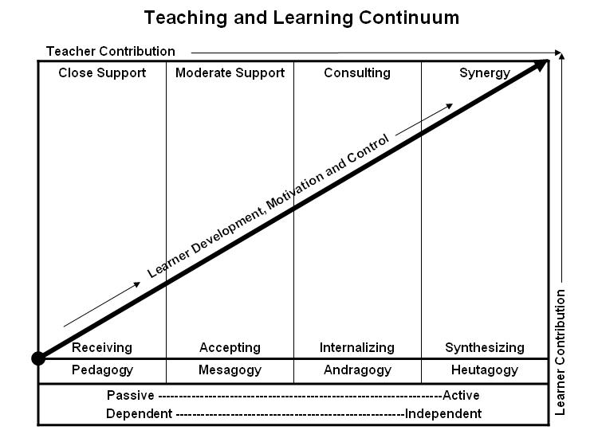
Learner’s Knowledge, Skills and Abilities
Indicator | Key Terms | Description
1 | Limited Knowledge and Proficiency | - Recognize basic information about the subject including terms and nomenclature.  - Students must demonstrate ability to recall information such as facts, terminology or rules related to information previously taught.  - Performs simple parts of the competency. Student requires close supervision when performing the competency.
2 | Moderate Knowledge and Proficiency | - Distinguish relationships between general principles and facts. Adopts prescribed methodologies and concepts.  - Students must demonstrate understanding of multiple facts and principles and their relationships, and differentiate between elements of information. Students state ideal sequence for performing task.  - Performs most parts of the competency with instructor assistance as appropriate.
3 | Advanced Knowledge and Proficiency | - Examines conditions, findings, or other relevant data to select an appropriate response.  - The ability to determine why and when a particular response is appropriate and predict anticipated outcomes.  - Students demonstrate their ability to seek additional information and incorporate new findings into the conclusion and justify their answers.  - Performs all parts of the competency without instructor assistance.
4 | Superior Knowledge and Proficiency | - Assessing conditions, findings, data, and relevant theory to formulate appropriate responses and develop procedures for situation resolution. Involves higher levels of cognitive reasoning.  - Requires students to formulate connections between relevant ideas and observations.  - Students apply judgments to the value of alternatives and select the most appropriate response.  - Can instruct others how to do the competency.  - Performs competency quickly and accurately.
A | Affective Objective | - Describes learning objectives that emphasize a feeling tone, an emotion, or a degree of acceptance or rejection.  - Objectives vary from simple attention to selected phenomena to complex but internally consistent qualities of character and conscience.  - Expressed as interests, attitudes, appreciations, values, and emotional sets or biases.

